**Cloud Computing**

**Diff b/w Cloud Computing & Grid Computing & Cloud Computing**

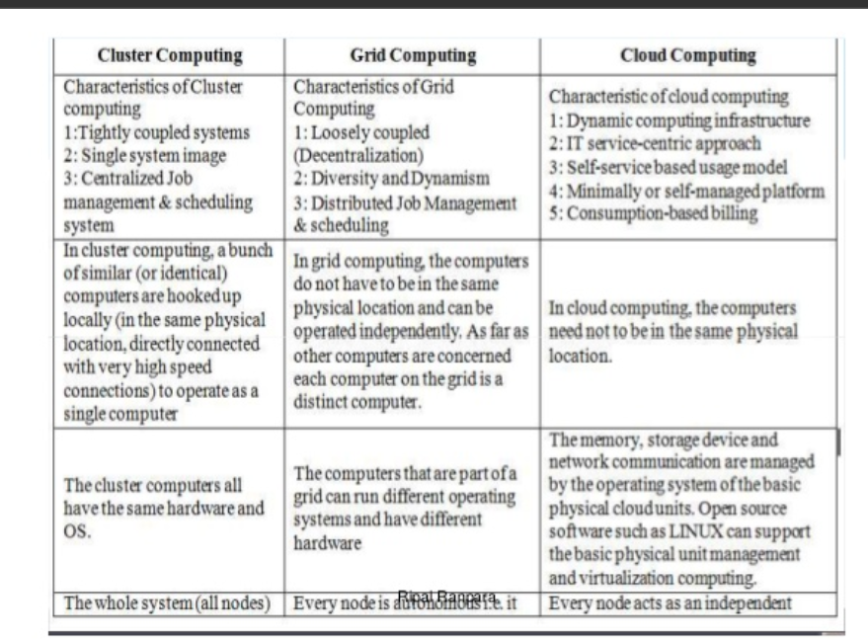

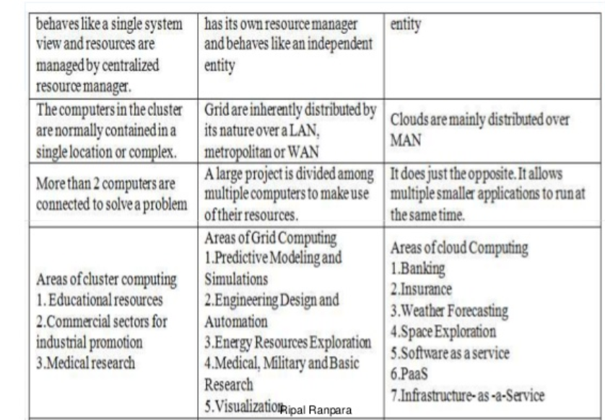

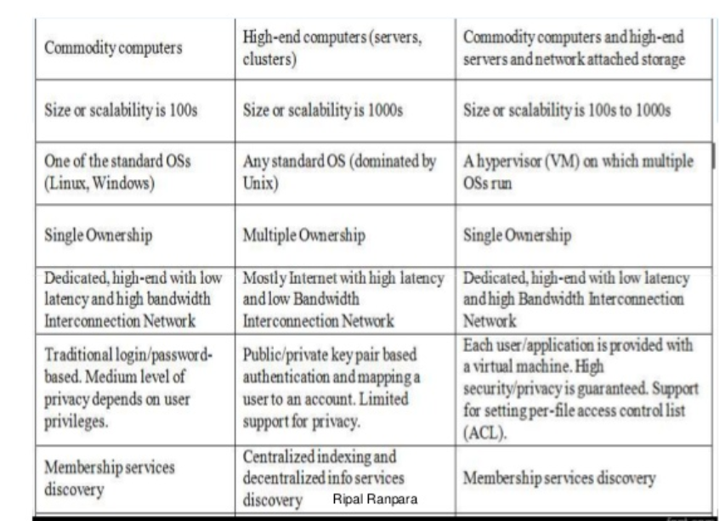

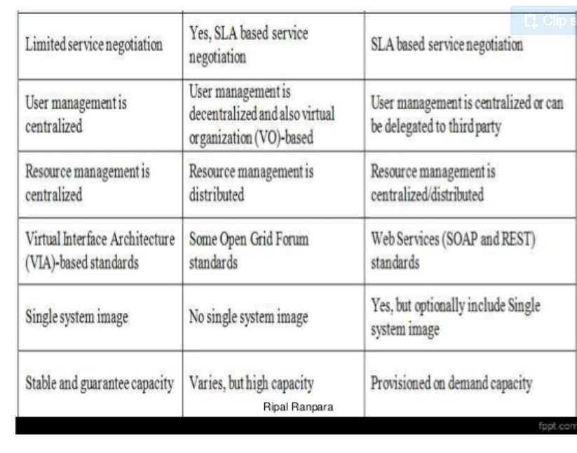

Introduction to cloud computing

**Cloud Computing NIST Model**

[NIST: National Institute of Standards and Technology](https://www.nist.gov/)

1. Cloud computing is a model for enabling convenient, on-demand network access to a shared pool of configurable computing resources (e.g., networks, servers, storage, applications, and services) that can be rapidly provisioned and released with minimal management effort or service provider interaction. This cloud model promotes availability and is composed of five essential characteristics (On-demand self-service, Broad network access, Resource pooling, Rapid elasticity, Measured Service); three service models (Cloud Software as a Service (SaaS), Cloud Platform as a Service (PaaS), Cloud Infrastructure as a Service (IaaS)); and, four deployment models (Private cloud, Community cloud, Public cloud, Hybrid cloud). Key enabling technologies include: (1) fast wide-area networks, (2) powerful, inexpensive server computers, and (3) high-performance virtualization for commodity hardware
2. The Cloud Computing model offers the promise of massive cost savings combined with increased IT agility.

Introduction to Cloud Computing

## **What is Cloud?**

The term **Cloud** refers to a **Network** or **Internet.** In other words, we can say that Cloud is something, which is present at remote location. Cloud can provide services over public and private networks, i.e., WAN, LAN or VPN.

Applications such as e-mail, web conferencing, customer relationship management (CRM) execute on cloud.

Q- What is Cloud Computing?

Ans- **Cloud Computing** is the use of hardware(mouse,monitor,keyboard,processing unit) and software(***internet browser: google chrome,firefox,internet explorer;Movie player***: Vlc,window media player;Operating System: Android, iOS, Linux, macOS, and Windows). to deliver a service over a network (typically the Internet). ... An **example** of a **Cloud Computing** provider is Google's Gmail. Gmail users can access files and applications hosted by Google via the internet from any device.

Ex**: Google Drive, GMAIL,FACEBOOK,DROPBOX,YAHOO**

* **cloud computing** is the delivery of **computing** services—including servers, storage, databases, networking, software, analytics, and intelligence—over the Internet (“the **cloud**”) to offer faster innovation, flexible resources, and economies of scale.
* **cloud computing** means storing and accessing data and programs over the Internet instead of your computer's hard drive.
* **Cloud is not about dedicated network.**

**Cloud broken down into 3 category**

1. Application
2. Networking
3. Storage

**Main Purpose Of Cloud Computing**

* **Cloud Computing** is a technology that uses the internet and **central** remote servers to maintain data and applications.
* **Cloud computing** allows consumers and businesses to use applications without installation and access their personal files at any computer with internet access.

**Cloud can have any of the four types of access: Public, Private, Hybrid, and Community.**

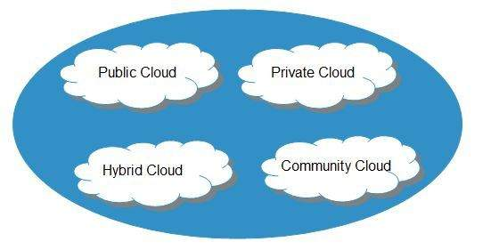

#### **Public Cloud**

The **public cloud** allows systems and services to be easily accessible to the general public. Public cloud may be less secure because of its openness.

#### **Private Cloud**

The **private cloud** allows systems and services to be accessible within an organization. It is more secured because of its private nature.

#### **Community Cloud**

The **community cloud** allows systems and services to be accessible by a group of organizations.

#### **Hybrid Cloud**

The **hybrid cloud** is a mixture of public and private cloud, in which the critical activities are performed using private cloud while the non-critical activities are performed using public cloud.

Introduction to Cloud Computing

* Cloud computing consists of three distinct types of computing services delivered remotely to clients via the internet. Clients typically pay a monthly or annual service fee to providers, to gain access to systems that deliver software as a service, platforms as a service and infrastructure as a service to subscribers. Clients who subscribe to cloud computing services can reap a variety of benefits, depending on their particular business needs at a given point in time.

## SAAS

Saas (Software as a Service) provides clients with the ability to use software applications on a remote basis via an internet web browser. Software as a service is also referred to as “software on demand”.

Clients can access SaaS applications from anywhere via the web because service providers host applications and their associated data at their location. The primary benefit of SaaS, is a lower cost of use, since subscriber fees require a much smaller investment than what is typically encountered under the traditional model of software delivery. Licensing fees, installation costs, maintenance fees and support fees that are routinely associated with the traditional model of software delivery can be virtually eliminated by subscribing to the SaaS model of software delivery. Examples of SaaS include: Google Applications and internet based email applications like Yahoo! Mail, Hotmail and Gmail.

## PAAS

PaaS (Platform as a Service) provides clients with the ability to develop and publish customized applications in a hosted environment via the web. It represents a new model for software development  
that is rapidly increasing in its popularity. An example of PaaS is Salesforce.com. PaaS provides a framework for agile software development, testing, deployment and maintenance in an integrated environment. Like SaaS, the primary benefit of PaaS, is a lower cost of use, since subscriber fees require a much smaller investment than what is typically encountered when implementing traditional tools for software development, testing and deployment. PaaS providers handle platform maintenance and system upgrades, resulting in a more efficient and cost effective solution for enterprise software  
development.

## IAAS

IaaS (Infrastructure as a Service) allows clients to remotely use IT hardware and resources on a “pay-as-you-go” basis. It is also referred to as HaaS (hardware as a service). Major IaaS players include companies like IBM, Google and Amazon.com. IaaS employs virtualization, a method of creating and managing infrastructure resources in the “cloud”. IaaS provides small start up firms with a major advantage, since it allows them to gradually expand their IT infrastructure without the need for large capital investments in hardware and peripheral systems.

SERVICE MODEL

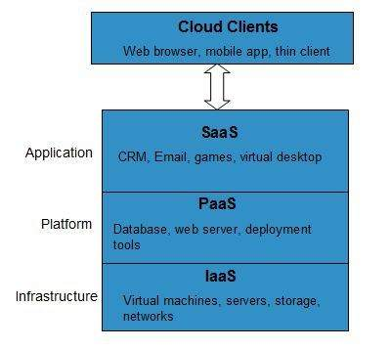

#### **Infrastructure-as-a-Service (IaaS)**

**IaaS** provides access to fundamental resources such as physical machines, virtual machines, virtual storage, etc.

#### **Platform-as-a-Service (PaaS)**

**PaaS** provides the runtime environment for applications, development and deployment tools, etc.

#### **Software-as-a-Service (SaaS)**

**SaaS** model allows to use software applications as a service to end-users.

History of Cloud Computing

* Before emerging the cloud computing, there was Client/Server computing which is basically a centralized storage in which all the software applications, all the data and all the controls are resided on the server side.If a single user wants to access specific data or run a program, he/she need to connect to the server and then gain appropriate access, and then he/she can do his/her business.
* Then after, distributed computing came into picture, where all the computers are networked together and share their resources when needed.
* In 1999, **Salesforce.com** started delivering of applications to users using a simple website. The applications were delivered to enterprises over the Internet, and this way the dream of computing sold as utility were true.
* In 2002, **Amazon** started Amazon Web Services, providing services like storage, computation and even human intelligence. However, only starting with the launch of the Elastic Compute Cloud in 2006 a truly commercial service open to everybody existed.
* In 2009, **Google Apps** also started to provide cloud computing enterprise applications.

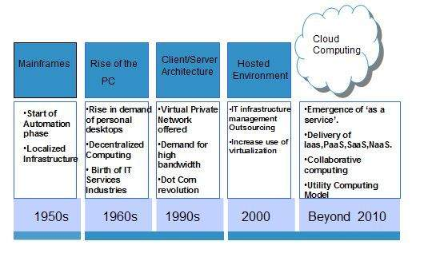

Fig: history of cloud computing

## **Advantages of Cloud Computing**

As we all know that Cloud computing is trending technology. Almost every company switched their services on the cloud to rise the company growth.

Here, we are going to discuss some important advantages of Cloud Computing-

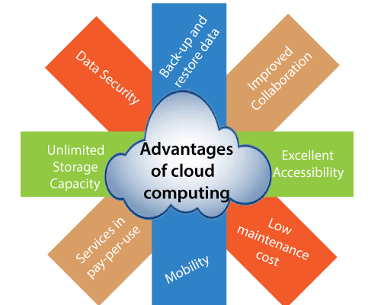

### 1) Back-up and restore data

Once the data is stored in the cloud, it is easier to get back-up and restore that data using the cloud.

### 2) Improved collaboration

Cloud applications improve collaboration by allowing groups of people to quickly and easily share information in the cloud via shared storage.

### 3) Excellent accessibility

Cloud allows us to quickly and easily access store information anywhere, anytime in the whole world, using an internet connection. An internet cloud infrastructure increases organization productivity and efficiency by ensuring that our data is always accessible.

### 4) Low maintenance cost

Cloud computing reduces both hardware and software maintenance costs for organizations.

### 5) Mobility

Cloud computing allows us to easily access all cloud data via mobile.

### 6) IServices in the pay-per-use model

Cloud computing offers Application Programming Interfaces (APIs) to the users for access services on the cloud and pays the charges as per the usage of service.

### 7) Unlimited storage capacity

Cloud offers us a huge amount of storing capacity for storing our important data such as documents, images, audio, video, etc. in one place.

### 8) Data security

Data security is one of the biggest advantages of cloud computing. Cloud offers many advanced features related to security and ensures that data is securely stored and handled.

## **Disadvantages of Cloud Computing**

A list of the disadvantage of cloud computing is given below -

### 1) Internet Connectivity

As you know, in cloud computing, every data (image, audio, video, etc.) is stored on the cloud, and we access these data through the cloud by using the internet connection. If you do not have good internet connectivity, you cannot access these data. However, we have no any other way to access data from the cloud.

### 2) Vendor lock-in

Vendor lock-in is the biggest disadvantage of cloud computing. Organizations may face problems when transferring their services from one vendor to another. As different vendors provide different platforms, that can cause difficulty moving from one cloud to another.

### 3) Limited Control

As we know, cloud infrastructure is completely owned, managed, and monitored by the service provider, so the cloud users have less control over the function and execution of services within a cloud infrastructure.

### 4) Security

Although cloud service providers implement the best security standards to store important information. But, before adopting cloud technology, you should be aware that you will be sending all your organization's sensitive information to a third party, i.e., a cloud computing service provider. While sending the data on the cloud, there may be a chance that your organization's information is hacked by Hackers.

### 5) Isolation Failure

This risk involves the failure of isolation mechanism that separates storage, memory, and routing between the different tenants.

### 6) Management Interface Compromise

In case of public cloud provider, the customer management interfaces are accessible through the Internet.

### 7) Insecure or Incomplete Data Deletion

It is possible that the data requested for deletion may not get deleted. It happens because either of the following reasons

* Extra copies of data are stored but are not available at the time of deletion
* Disk that stores data of multiple tenants is destroyed.

8) Limited feature

9) High speed of data require

## **Benefits**

* One can access applications as utilities, over the Internet.
* One can manipulate and configure the applications online at any time.
* It does not require to install a software to access or manipulate cloud application.
* Cloud Computing offers online development and deployment tools, programming runtime environment through **PaaS model.**
* Cloud resources are available over the network in a manner that provide platform independent access to any type of clients.
* Cloud Computing offers **on-demand self-service.** The resources can be used without interaction with cloud service provider.
* Cloud Computing is highly cost effective because it operates at high efficiency with optimum utilization. It just requires an Internet connection
* Cloud Computing offers load balancing that makes it more reliable.

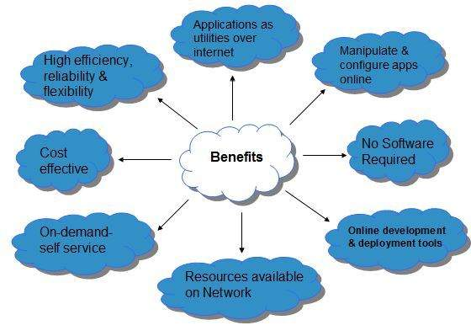

## **Characteristics of Cloud Computing**

There are four key characteristics of cloud computing. They are shown in the following diagram:

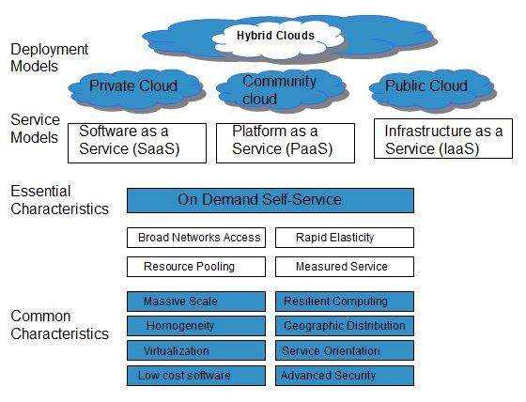

### On Demand Self Service

Cloud Computing allows the users to use web services and resources on demand. One can logon to a website at any time and use them.

### Broad Network Access

Since cloud computing is completely web based, it can be accessed from anywhere and at any time.

### Resource Pooling

Cloud computing allows multiple tenants to share a pool of resources. One can share single physical instance of hardware, database and basic infrastructure.

### Rapid Elasticity

It is very easy to scale the resources vertically or horizontally at any time. Scaling of resources means the ability of resources to deal with increasing or decreasing demand.

The resources being used by customers at any given point of time are automatically monitored.

### Measured Service

In this service cloud provider controls and monitors all the aspects of cloud service. Resource optimization, billing, and capacity planning etc. depend on it.

## **Grid Computing**

* Grid computing is also called as "**distributed computing**." It links multiple computing resources (PC's, workstations, servers, and storage elements) together and provides a mechanism to access them.
* The main advantages of grid computing are that it increases user productivity by providing transparent access to resources, and work can be completed more quickly.

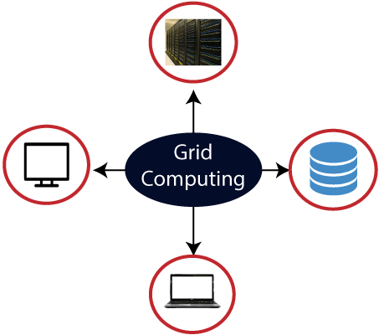

GRID CHARACTERISTICS

1. Resource sharing

2. Geographical distribution

3. Heterogeneity

4. Large scale

5. Multiple administrations

6. Resource coordination

7. Transparent access

8. Dependable access

9. Consistent access

10. Pervasive access

11. Decentralization (Loosely coupled)

12. Dynamism and Diversity

13. Distributed Job Management & scheduling

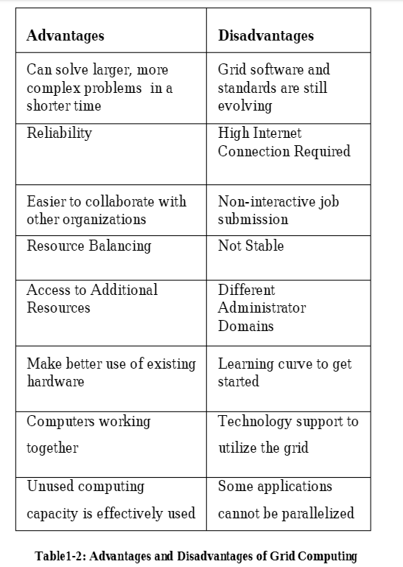

**BENEFITS OF GRID COMPUTING**

1. Enables applications to be easily scaled

2. Better utilization of underused resources

3. Enables the linking of cheaper computers together,

instead of spending a lot of money on one machine

4. Technologies being used are open source, trust and

transparency is encouraged

5. Increased reliability of computing

6. Allows the sharing of computer resources across

networks

7. Parallelization of processing

8. Resource balancing

DRAWBACKS OF GRID COMPUTING

* Proprietary approach should be eliminated
* Reliability and Complexity
* There is a single point of failure if one unit on the grid

Degrades

Grid Use

1. Distributed supercomputing

2. High-throughput computing

3. On-demand computing

4. Data-intensive computing

5. Collaborative computing

6. Multimedia computing

CLUSTER COMPUTING CHARACTERISTICS

1. Tightly coupled systems

2. Single system image

3. Centralized Job management & scheduling system

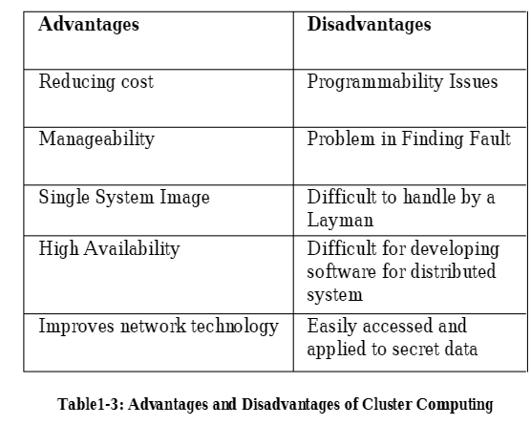

**VIRTUALIZATION**

Virtualization is a building block in today’s computer

Infrastructures. Virtualization means to create

a virtual version of a resource or device, like storage

Device, server, network or even an OS where the framework

Divides the resource into one or more execution environments.

**Benefits**

Visualization include such as:

1. Testing and learning

2. VMs are portable

3. Decreased hardware investment

4. Lower maintenance costs

5. Improved Performance and disaster recovery

6. Lower energy consumption, environment friendly

7. Easier Migration into the cloud

8. Easily host a guest operating system(VM)

9. Create lots of webservers

**DRAWBACKS OF VIRTUALIZATION**

1. High Risk in Physical fault

2. Single point of failure

3. Powerful machines

4. Lower performance

5. Specific applications that can't be virtualized

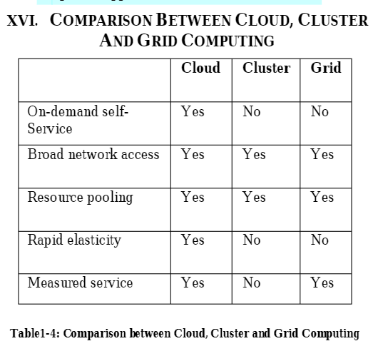

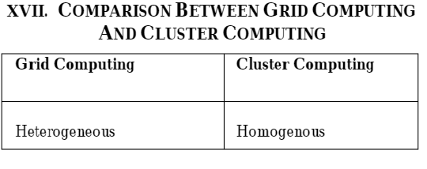

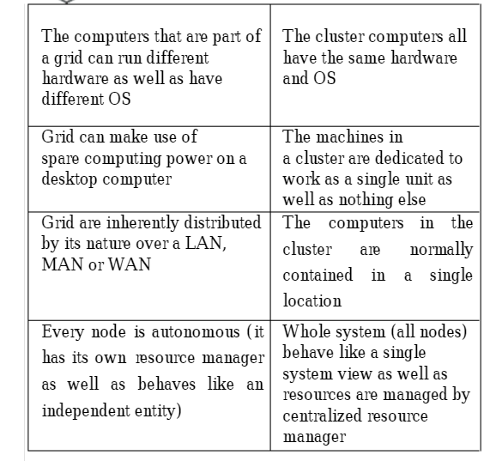

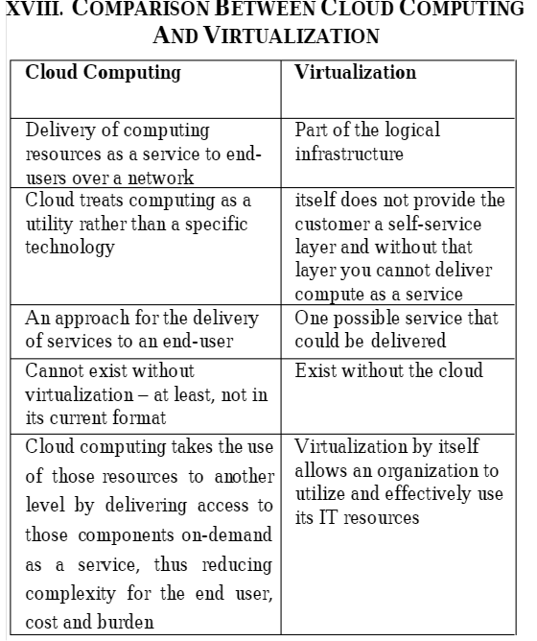

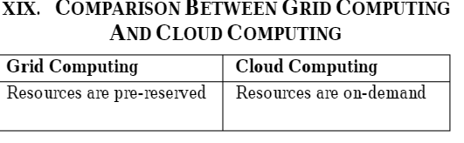

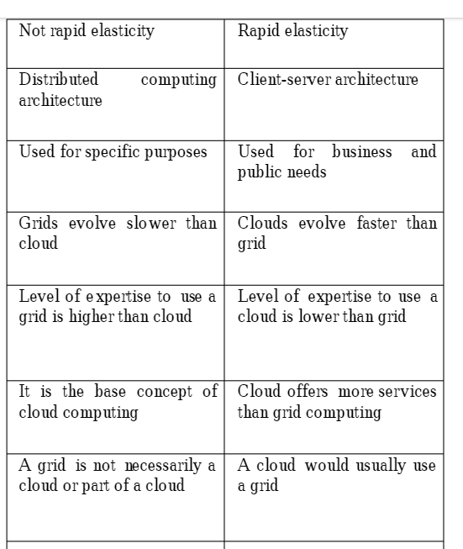

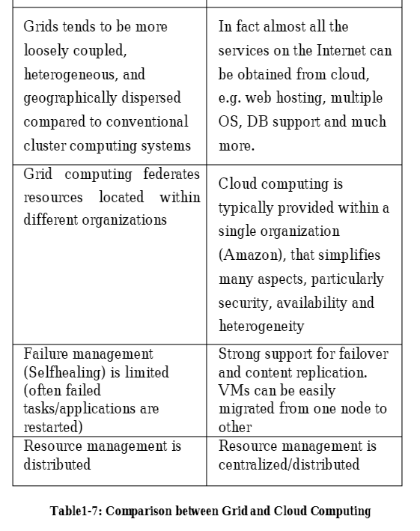

Difference between client-server and cloud computing

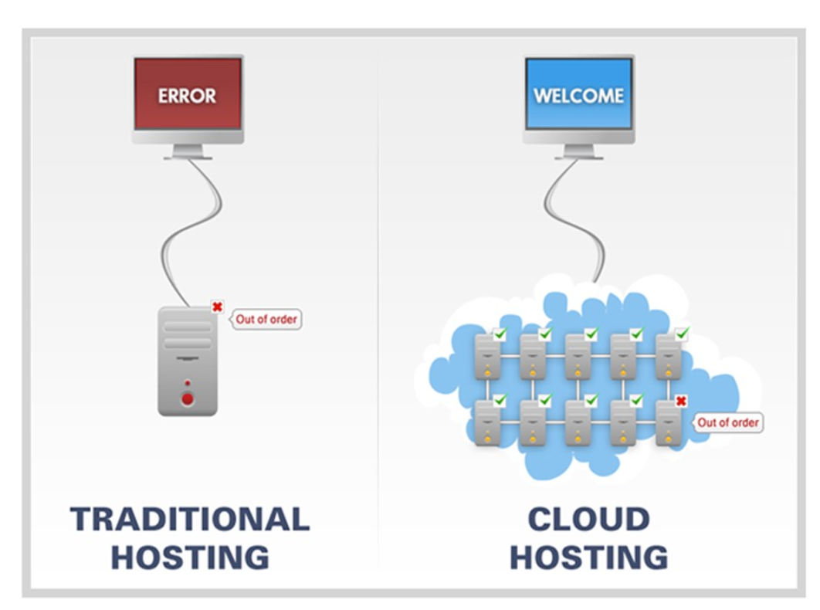

* In a client/server architecture, one logs on to a server, authenticating their identification against credentials saved on the server, not on the local computer even before accessing their computer’s operating system. Whereas cloud access usually occurs without the need for manual user-provided credentials, after the user has logged on to the computer, or other devices, utilizing locally-saved credentials.
* Both of them provide storage of the user computer for necessary files.
* Client/server architectures are normally deployed in organizations where control of the user computer and computer access, such as centrally-stored user credentials, operating system updates, or updating user applications are centrally administered and directed.
* The primary difference in cloud computing and traditional networking or hosting is the implementation, and in one word that is “virtualization.” Virtualization allows for extensive scalability, giving clients virtually limitless resources.
* In a traditional networking setup, the server is settled in hardware and if you want to scale up to more users than the current hardware can support, you would need to allocate more money for upgrades and there would still be a limit.
* A Cloud provider is able to scale resources without issues and the client will only need to pay for what they use. In traditional networking, you need to pay for everything; the hardware, the installation, maintenance, or even just rent it for a monthly fixed price, even if you only need a small bit of resource.

HOW DOES CLOUD WORKS

The cloud has to be divided into different layers. These layers are the **front-end** and **back-end** layers. Front-end layer is that part of the cloud which users can interact with. For example, when we log in to our Gmail account, we see the UI (user interface) where everything works on event-driven buttons and graphics. Similarly, a software also runs in the front end of the cloud. Again, the back-end comprises of hardware as well as software that delivers the back-end data from the database to the front end.

* Cloud uses a network layer to connect different devices to provide access to resources that are residing in the centralized data center of the cloud. Cloud technology users can use the data center through the company's network or internet facilities. This technology provides various advantages; as users can access the cloud from anywhere at any time, but the network bandwidth should have to be more. This technology not only facilitates desktop and laptop users but the mobile users can also access their business systems based on their demand.
* As we already know that cloud computing is fast and efficient, applications running on the cloud take advantages of flexibility and computing power, i.e., the speed of processing a task.
* In the Cloud computing system architecture, there is another mechanism of shifting the workload. Local machines don't have to perform massive lifting operations when it comes to run applications. Cloud technology can handle those heavy loaded tasks automatically easily and efficiently. This brings down the hardware & software demands. The only thing that the users have to think is the cloud computing interface software of the system, which works merely as a web-browser in the front end of the user. The cloud's network takes care of the rest along with the back-end.

The back-end is connected through a virtual network or internet. Other than that, there are few more components such as Middleware, cloud resources, etc. that includes the cloud computing architecture. The backend is used by service providers that include various servers, computers, virtual machines & data storage facilities that are combined to form the cloud technology. Its dedicated server handles each application in the system. The front end includes the cloud computing system or network that is used for accessing the cloud computing system.

**The back-end has two principal responsibilities:**

1. Provides traffic control mechanisms, security postures & governing the protocols
2. To employ those internet protocols that are connected to the networked computer for communication

* One central server is used to manage the entire cloud system architecture. The server is responsible for handling the smoothness of traffic without disruption/disturbance. Middleware is a particular type of software that is used to perform processes & also connects networked computers. Depending on the demand of client/user, the storage is provided by the cloud technology's service provider.

**EXAMPLE**

* Assume that you are an executive at a very big corporation. Your particular responsibilities include to make sure that all of your employees have the right hardware and software they need to do their jobs. To buy computers for everyone is not enough. You also have to purchase software as well as software licenses and then provide these softwares to your employees as they require. Whenever you hire a new employee, you need to buy more software or make sure your current software license allows another user. It is so stressful that you have to spend lots of money.
* But, there may be an alternative for executives like you. So, instead of installing a suite of software for each computer, you just need to load one application. That application will allow the employees to log-in into a Web-based service which hosts all the programs for the user that is required for his/her job. Remote servers owned by another company and that will run everything from e-mail to word processing to complex data analysis programs. It is called cloud computing, and it could change the entire computer industry.

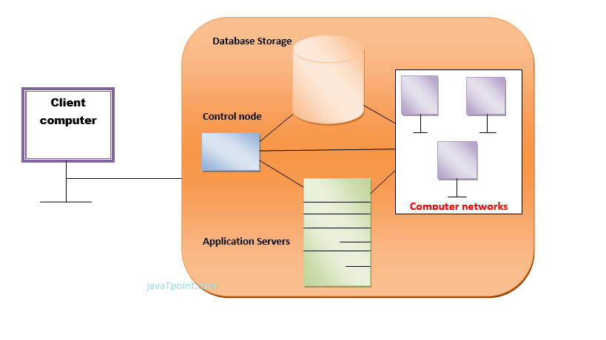

* In a cloud computing system, there is a significant workload shift. Local computers have no longer to do all the heavy lifting when it comes to run applications. But cloud computing can handle that much heavy load easily and automatically. Hardware and software demands on the user's side decrease. The only thing the user's computer requires to be able to run is the cloud computing interface software of the system, which can be as simple as a Web browser and the cloud's network takes care of the rest.

**Role of Networks in Cloud computing, protocols used**

* The **network** plays a key **role** in the delivery of **cloud**-based services as it provides a means to connect every IT system and has the ability to provision and scale these resources to meet application and end-user requirements.

**Some of cloud computing protocols:**

* Gossip Protocol
* Connection-less n/w protocol (CLNP)
* State Routing Protocol (SRP)
* Internet Group Management Protocol (IGMP)
* Secure Shell protocol (SSHP)
* Coverage Enhanced Ethernet Protocol (CEE)
* Media Transfer Protocol (MTP)

**SERVICE**

**XAAS**: Anything as a service

It comprises as 3 thing as SaaS, paas , iaas

### The future market for XaaS

The combination of cloud computing and ubiquitous, high-bandwidth, global internet access provides a fertile environment for XaaS growth.

**VIRTUALIZATION**

* **Virtualization** is the "creation of a virtual (rather than actual) version of something, such as a server, a desktop, a storage device, an operating system or network resources".
* In other words, Virtualization is a technique, which allows to share a single physical instance of a resource or an application among multiple customers and organizations. It does by assigning a logical name to a physical storage and providing a pointer to that physical resource when demanded.

## **What is the concept behind the Virtualization?**

* Creation of a virtual machine over existing operating system and hardware is known as Hardware Virtualization. A Virtual machine provides an environment that is logically separated from the underlying hardware.
* The machine on which the virtual machine is going to create is known as **Host Machine** and that virtual machine is referred as a **Guest Machine**

## **Types of Virtualization:**

1. Hardware Virtualization.
2. Operating system Virtualization.
3. Server Virtualization.
4. Storage Virtualization.
5. Network Virtualization

### 1) Hardware Virtualization:

* When the virtual machine software or virtual machine manager *(VMM) is directly installed on the hardware system* is known as hardware virtualization.
* The main job of hypervisor is to control and monitoring the processor, memory and other hardware resources.
* After virtualization of hardware system we can install different operating system on it and run different applications on those OS.

**Usage:**

Hardware virtualization is mainly done for the server platforms, because controlling virtual machines is much easier than controlling a physical server.

### 2) Operating System Virtualization:

* When the virtual machine software or virtual machine manager *(VMM) is installed on the Host operating system* instead of directly on the hardware system is known as operating system virtualization.

**Usage:**

Operating System Virtualization is mainly used for testing the applications on different platforms of OS.

### 3) Server Virtualization:

* When the virtual machine software or virtual machine manager *(VMM) is directly installed on the Server system* is known as server virtualization.

**Usage:**

Server virtualization is done because a single physical server can be divided into multiple servers on the demand basis and for balancing the load.

### 4) Storage Virtualization:

* Storage virtualization is the *process of grouping the physical storage from multiple network storage devices so that it looks like a single storage device*.
* Storage virtualization is also implemented by using software applications.

**Usage:**

Storage virtualization is mainly done for back-up and recovery purposes.

5 Network Virtualization

## **How does virtualization work in cloud computing?**

**Virtualization** plays a very important role in the cloud computing technology, normally in the cloud computing, users share the data present in the clouds like application etc, but actually with the help of virtualization users shares the Infrastructure.

The **main usage of Virtualization Technology** is to provide the applications with the standard versions to their cloud users, suppose if the next version of that application is released, then cloud provider has to provide the latest version to their cloud users and practically it is possible because it is more expensive.

To overcome this problem we use basically virtualization technology, By using virtualization, all severs and the software application which are required by other cloud providers are maintained by the third party people, and the cloud providers has to pay the money on monthly or annual basis.

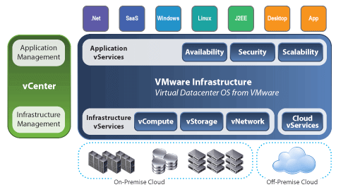

## **Conclusion**

Mainly Virtualization means, running multiple operating systems on a single machine but sharing all the hardware resources. And it helps us to provide the pool of IT resources so that we can share these IT resources in order get benefits in the business.